Machine Translated by Google

WORKSHEET // THEME: CLOTHES

CLOTHING CONSUMPTION BEFORE AND NOW

CLOTHING CONSUMPTION IN THE PAST
Here you note your findings from the interview with an older person.
CLOTHING CONSUMPTION NOW
Here you note your findings from the interview with a classmate.

DESCRIBE DIFFERENCES AND SIMILARITIES
Here you note the differences and similarities that the interviews have shown you.

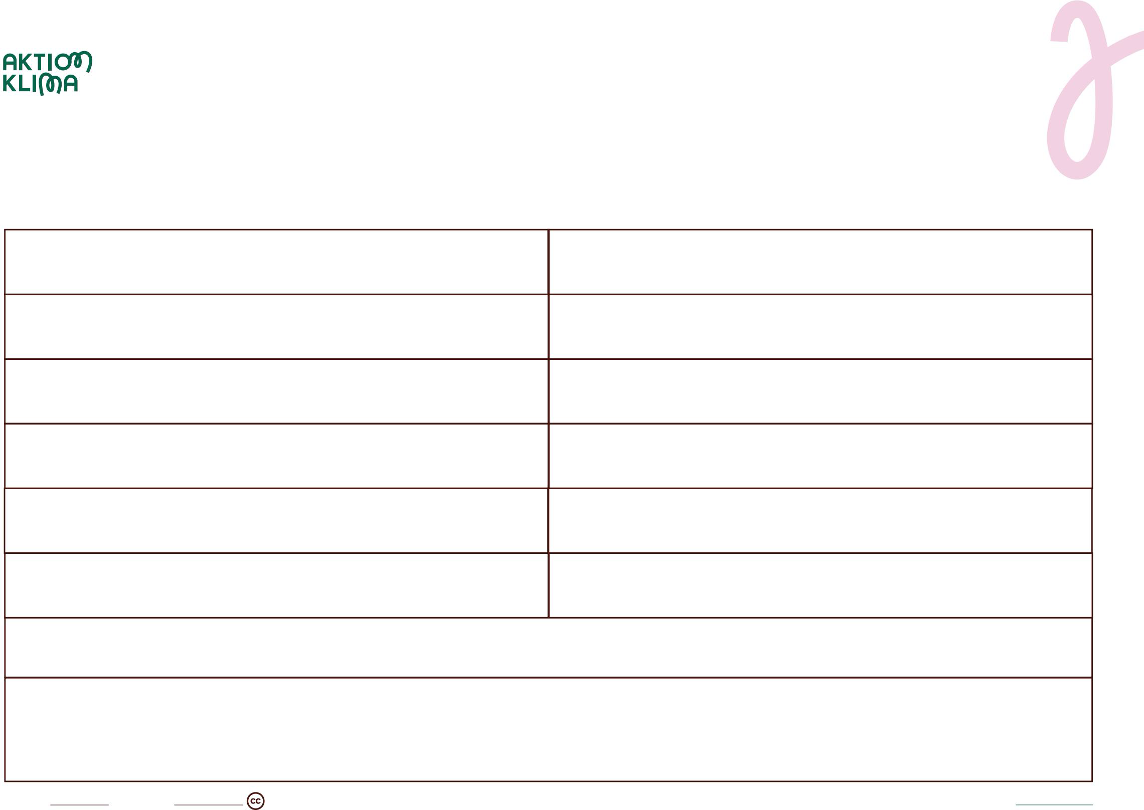
Developed by &LEARNING with support from the Villum Foundation
aktionklima.dk

