All rights reserved. Global News (c) 2014 - 2024

A world in development

Africa has difficulty getting rid of unwanted recycled clothing

Recycled clothing from the West can end up polluting or out-competing local producers in Africa. Several countries have tried to ban it, but most have been pressured to abandon it.

A woman brings new goods to Ghana's largest market, Kantamanto
Photo: Jonathan Torgovnik/ Getty Images

Thomas Jazrawi
January 11, 2022
Reading time: 3 min

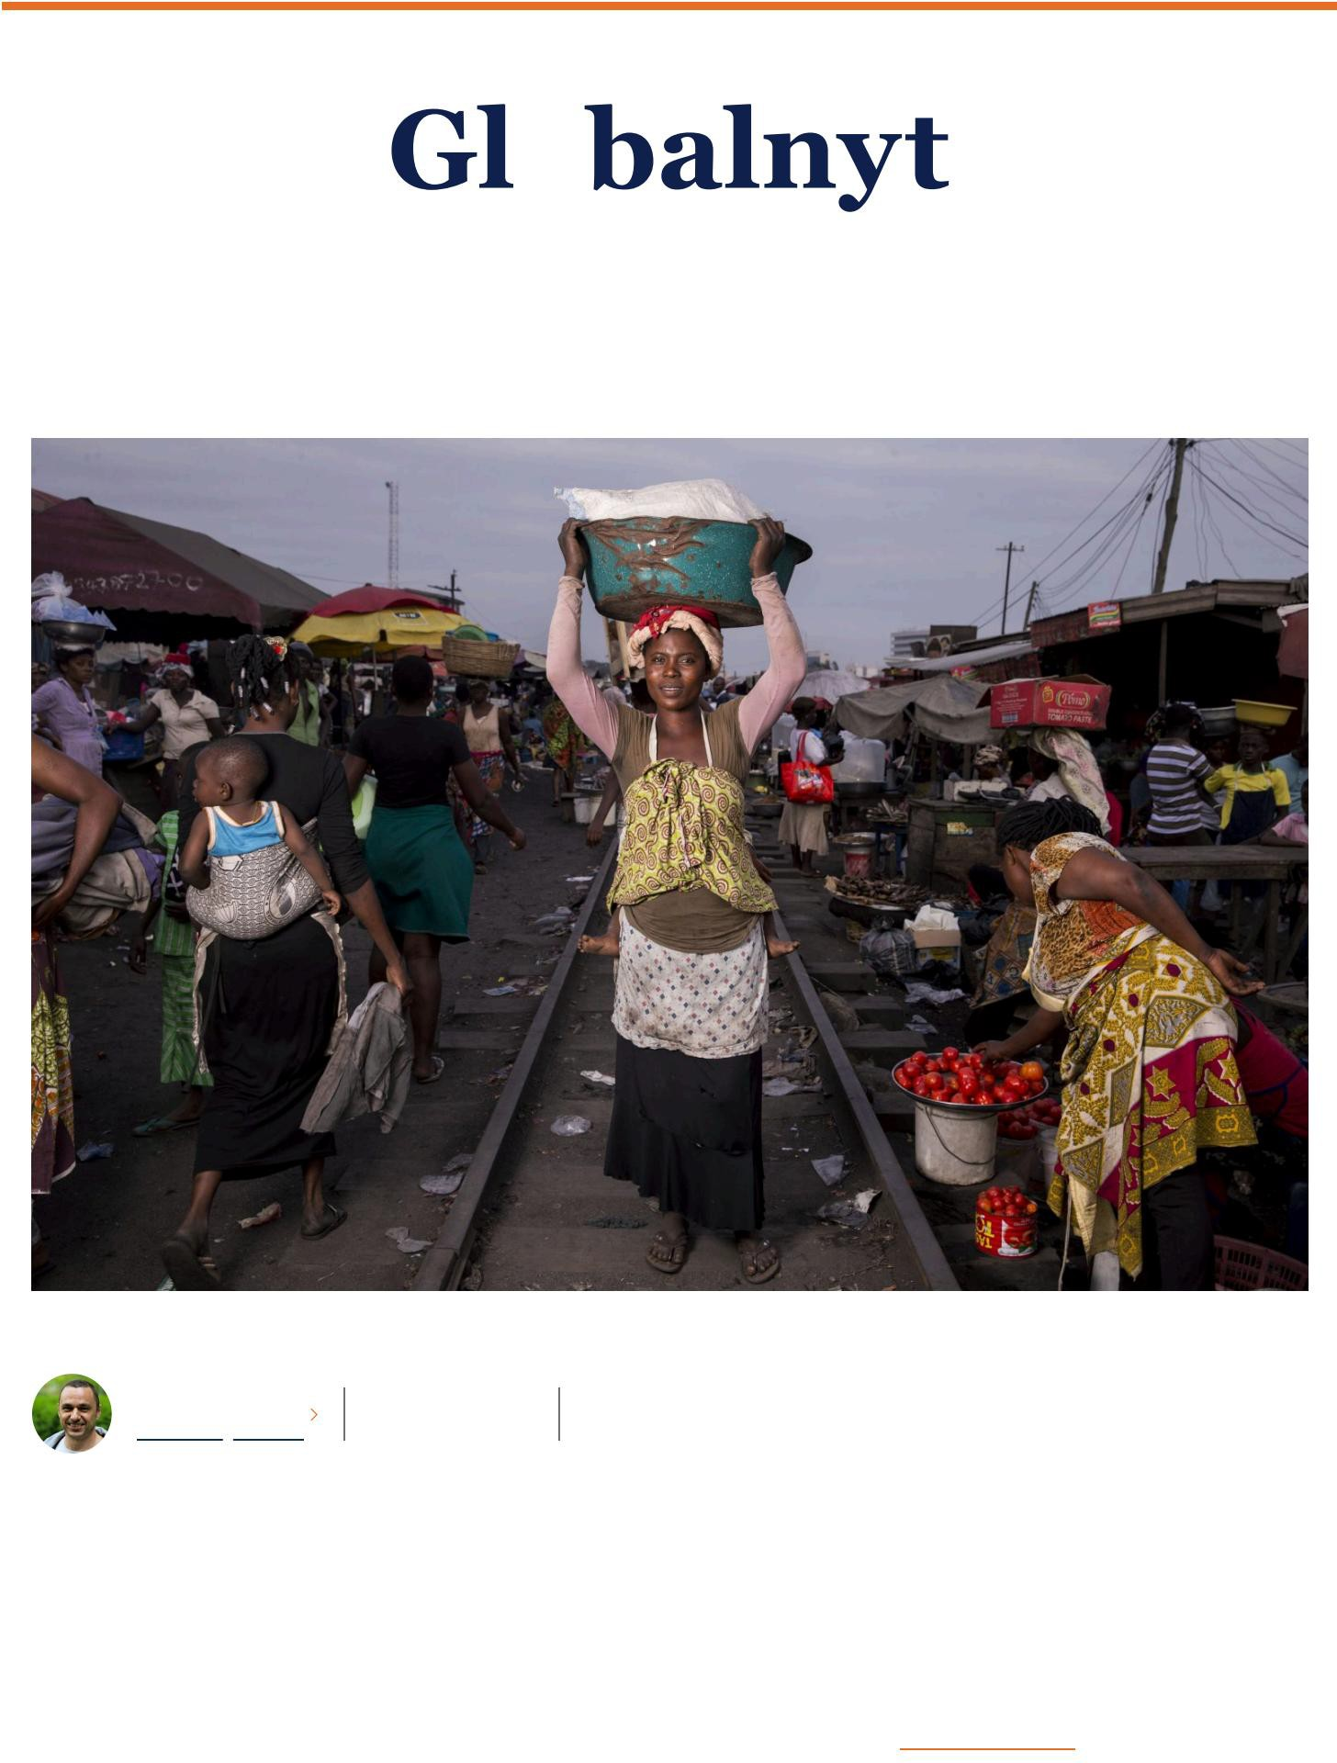
Discarded clothes from wealthy people in the West to poor Africans. It sounds like a good idea, but there is much evidence that these schemes do more harm than good.
That is the perception of many in Ghana. In the center of the capital Accra is the country's largest clothing market, Kantamanto, where there are a lot of clothing stalls. Much of the clothing is second-hand from the West, but the quality is often poor.

This means that piles of clothes cannot be resold and end up in landfills or in the ocean.

“Some of the clothes are made of polyester and synthetic fabrics that end up in the ocean and suffocate the fish and marine life
there,” Roberta Annan, who is a Goodwill Ambassador for the UN and founder of the African Fashion Foundation, tells Deutsche Welle.

The American organization OR Foundation estimates that 15 million pieces of used clothing arrive in Ghana every week.

Fast fashion

Not far from Kantamanto there is a huge mountain of garbage, a large part of which is discarded textiles. It is located on the coast, so some of the garbage ends up in the sea. The harmful chemicals in the clothes are thus damaging the aquatic environment, Justice Adoboe from the Ghana Water and Sanitation Journalists Network (GWJN) tells Deutsche Welle. It is a local organization that

wants to focus on the back side of the recycling adventure.

The challenge has its roots in fast fashion, and the way fashion works in the West. Fashion clothes are specifically limited to a period until a new trend takes over. At the same time, a lot of clothes are produced so that they don't last very many trips in the washing machine.


For example, each Dane buys around 16 kilos of clothes per year, and according to the Danish Consumer Council, the cheapest clothes are used 7-8 times. However, some of the clothes are not suitable for recycling. According to the Danish Competence Centre for
Waste and Resources, around 90,000 tonnes of textiles are discarded annually in Denmark. Unusable used clothing also ends up in
Africa. When containers with recycled clothing arrive in Accra, there is a demand for the best quality, but around 40 percent of the many tons of used clothing are discarded, estimates the OR Foundation.
Rwanda punished for ban

Some of the recycled clothing that ends up in Africa helps provide a livelihood for local sellers, but it also puts pressure on local textile production. This has led several African countries to consider banning imports.
Previously, the East African Community (EAC) worked towards introducing a ban on receiving used clothing from the West from 2019. However, it did not come to fruition, as the initiative was very unpopular in the United States.
The US authorities responded by threatening to withdraw favorable trade conditions. These conditions are under the Africa Growth and Opportunity Act (EAC), which ensures that a large number of countries in Africa do not have to pay tariffs when exporting goods to the US. The threats caused Kenya, Tanzania and Uganda to change course. But Rwanda stood firm and imposed a ban in 2018.

The US responded by withdrawing the country from AGOA, which is quite exceptional. Normally, it takes considerably more for nations to lose benefits. In fact, Rwanda is the only country to have been pulled out of the scheme due to “trade barriers” to the import of used
textiles, according to the latest AGOA report. this January. Right now, there are ten countries in sub-Saharan Africa that have lost the benefits,
typically as a result of human rights violations or political violence.

“The United States’ highest foreign policy goal in Africa seems to be less about human rights and democratic freedom than about protecting small businesses,” says Garth Frazer, a professor at the University of Toronto, in an op-ed in The
Conversation

The new US administration under Joe Biden has excluded Ethiopia, Guinea and Mali from AGOA due to, among other things, human rights violations and lack of legal certainty, but not including Rwanda again.
Correction: We wrote in the original article that 90,000 tons of textiles end up incinerated. According to DAKOFA, 90,000 tons of textiles are discarded as normal waste annually. About two-thirds of this ends up incinerated.
ÿ ÿ ÿ ÿ

All rights reserved. Global News (c) 2014 - 2024

CONTACT

Pile Allé 41, kld.
DK-2000
Frederiksberg

ansvarshavende@globalnyt.dk

CVR 32725945

Bank: Nordea reg. no. 2255 – account no. 8971 797 186

