Sustainable fashion initiatives (text + photos)
A Repair Café is a community event where people bring broken household items, like appliances or clothing, to be repaired for free by skilled volunteers who also share their knowledge. You can bring your broken stuff, and also contribute by offering your skills or services in repairing. Clothing is often part of the repair café.
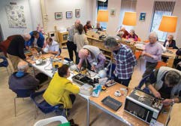
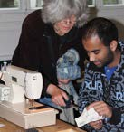

Sources: https://repaircafeeindhoven.nl/ & https://www.repaircafe.org/en/repairing-clothes-and-textiles/.

A Clothing Swap is an event where participants bring clothing and other accessories they no longer want and exchange them for different items brought by other attendees, allowing everyone to refresh their wardrobe sustainably without buying new items.
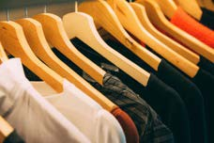
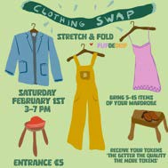

https://www.pexels.com/nl-nl/foto/geassorteerde-kleding-996329/ & https://www.stretchandfold.nl/events/clothing-swap.

The Clothing Loop is an initiative that offers an easy way for people to swap clothes with others in their own neighborhood. The idea is simple: (large) bags filled with clothes travel along a route past all participants in a certain city or district. Did you receive the bag from the person before you in the Loop? Take any items you like, and put clothing items in the bag that are in good condition and ready for a new owner. Then you bring the bag to the next person on the list. Not all participants know each other, so it additionally increases the sense of community in the neighborhood. The Clothing Loop helps in reusing and repurposing clothing, instead of throwing it away and buying new clothing.


https://www.clothingloop.org/en/about/

