The R-ladder of clothing (text)

- 1. Refuse: Refuse to buy clothing made from unsustainable materials or from brands with unethical practices. Consciously choose not to buy items you don’t really need. This helps to prevent unnecessary production and waste. The Fabricant is a digital fashion house e.g. (picture): clothing producers or designers can here sketch, and design their clothing, without using explicit materials. This saves many discarded pieces of textile.


- 2. Rethink: Rethink how you use clothing: do you really need something new, or can you borrow, rent, or swap? By changing your habits you can reduce how much clothing you need and use it more efficiently. Fashion libraries are an example of this (picture), where you can rent clothing for events, and return them afterwards.
Therefore you do not need to buy a very specific piece of clothing, but can rather share that one piece of clothing with many others whenever you need it.
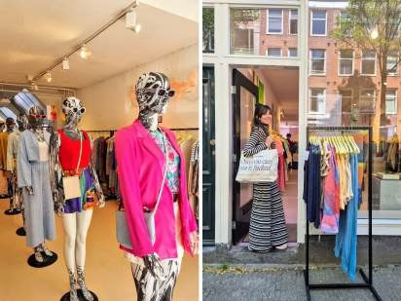

- 3. Reduce: Buy fewer clothes and focus on timeless, high-quality pieces that last longer. An example of this is a so-called 'capsule wardrobe', where you buy a few pieces of clothing, which can all be combined throughout the seasons, thereby creating infinite possibilities for outfits (picture). Consuming less helps reduce demand for new production and lowers environmental impact.

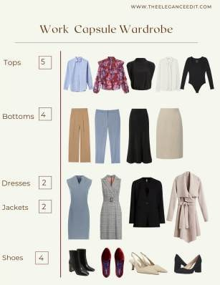

- 4. Re-use: Wear second-hand clothing or give your own clothes a second life through thrift stores or clothing swaps (picture). This extends the lifespan of garments and keeps them out of the waste stream.
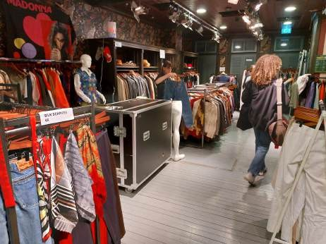

- 5. Repair: Fix damaged clothing by sewing a loose hem, replacing buttons, or patching holes. Even small repairs and adjustments help keep clothing wearable for longer. High-quality clothing which does not mix materials are easier to repair (picture).

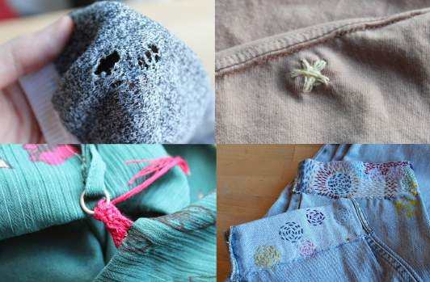

- 6. Refurbish: Refresh or update garments by professionally cleaning, repairing, or restyling them. You might dye faded fabric or alter an outdated fit to make it feel new again (picture).
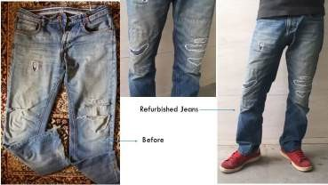

- 7. Remanufacture: Use parts of old garments to create new clothing, like making a jacket from several pairs of old jeans, or even making new jeans from parts of old jeans (pictures)! This is often done by sustainable fashion brands or designers.
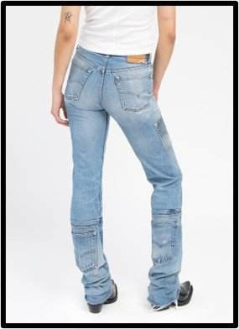

- 8. Re-purpose: Give old clothes a new function, like turning worn-out t-shirts into cleaning rags, pillow covers, or tote bags. Or turning curtains into a shirt (picture). This gives materials a second life in a different form.
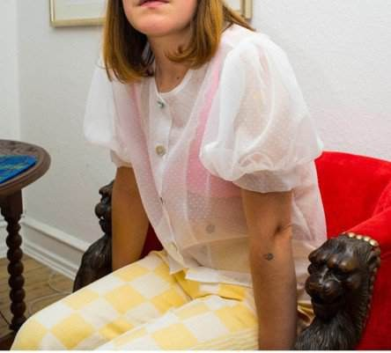
- 9. Recycle: Worn-out textiles can be processed into new fibers for things like insulation, stuffing, or low-grade fabric. The material is broken down, though usually with some loss of quality. However, this is the new 'normal' now, leading to huge piles of clothing (picture).
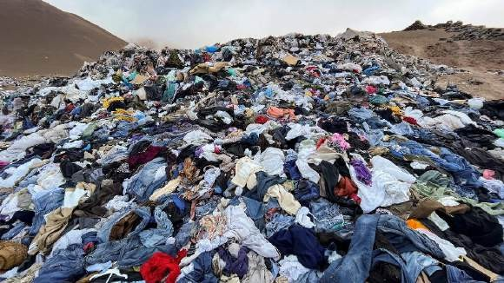

- 10. Recover: If clothing can no longer be reused or recycled, it may be incinerated to recover energy. This is the least sustainable option, as the materials are lost in the process.

