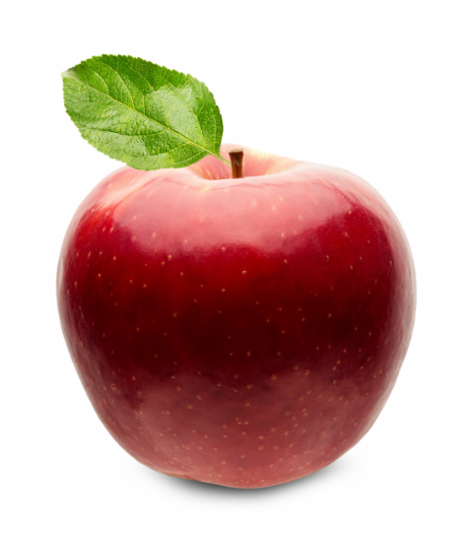 | Local and seasonal fruit
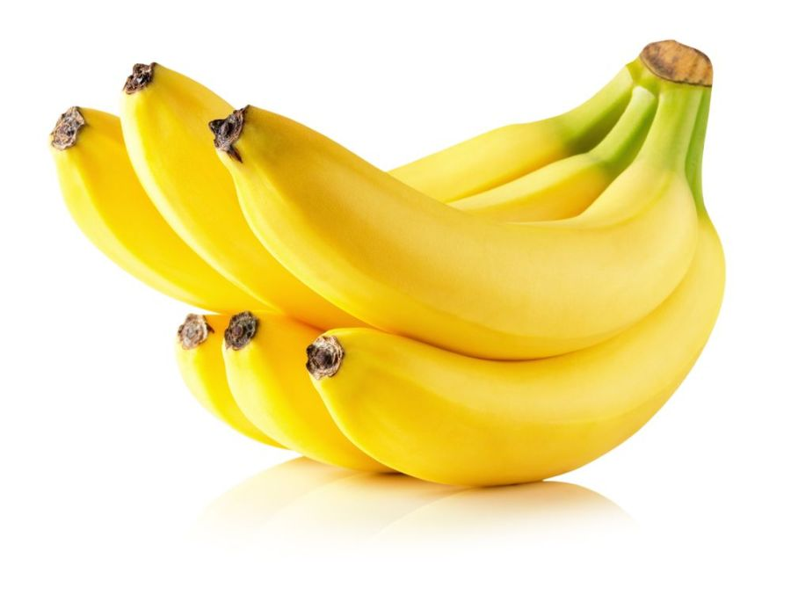 | Long transport, high food miles
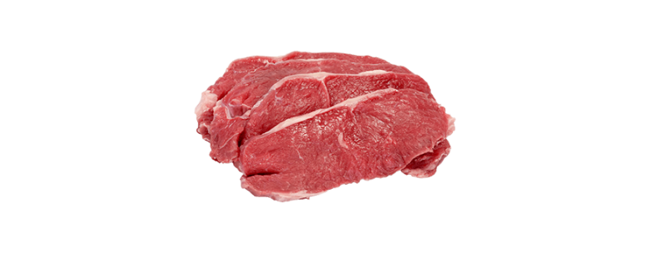 | High CO₂  Footprint
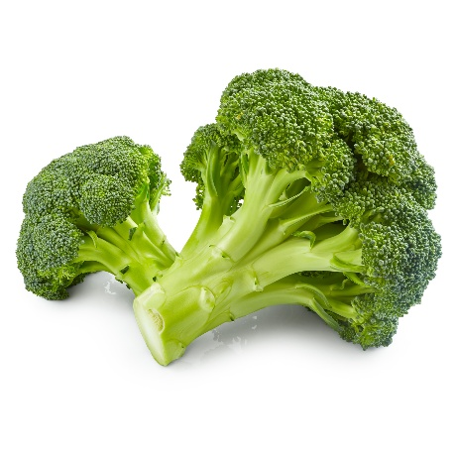 | Healthy, plant-based
 | Made from cocoa beans, long supply chain
 | Sustainable alternative to bottled water
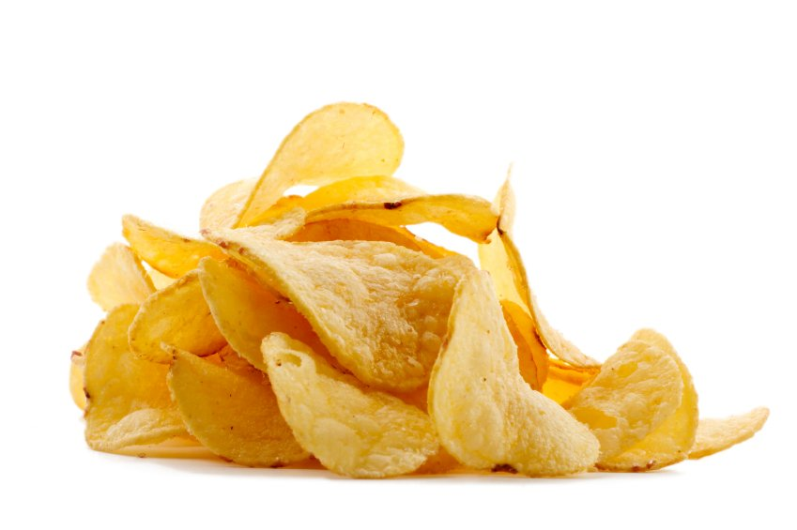 | Processed food, lots of salt/fat
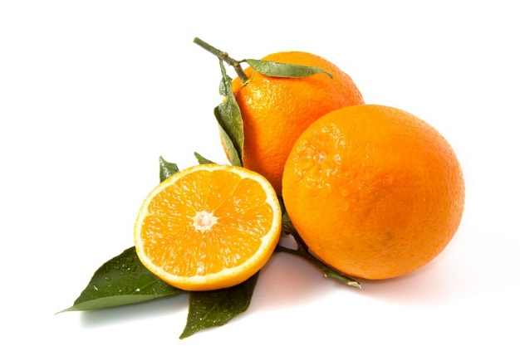 | Rich in vitamin C, often transported long distances
 | Animal product, source of protein
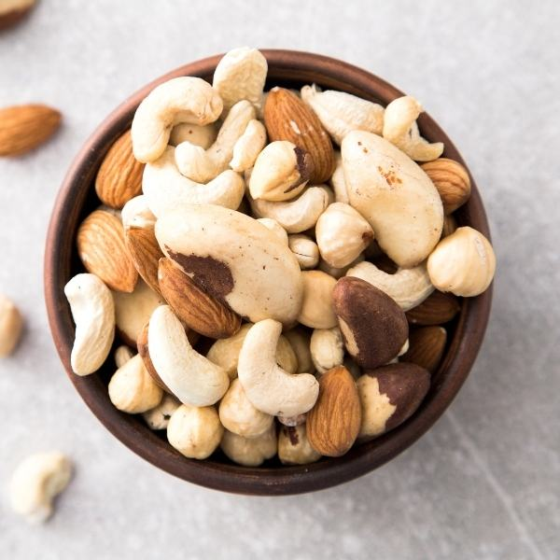 | Plant protein, can require lots of water (almonds)
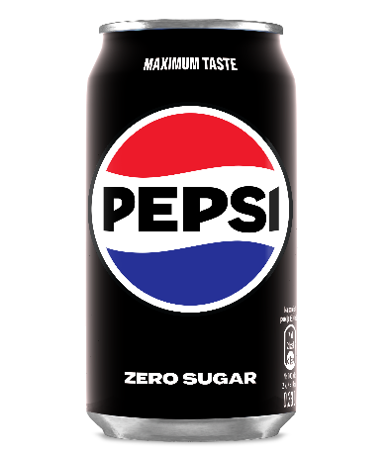 | Sugary drink, lots of packaging waste

